Fact sheet demosite – SenTec– benodigde informatie
Pagina 1:
Naam: SenTec – Sensor Test Centre; Sensor and data-measuring applications
Foto’s:
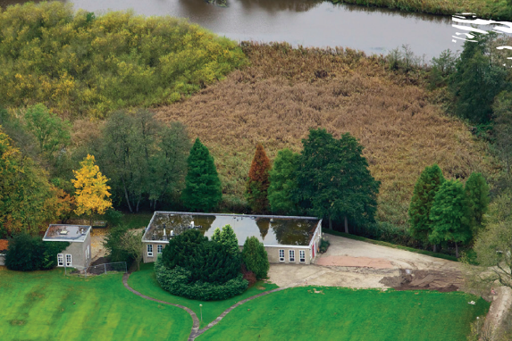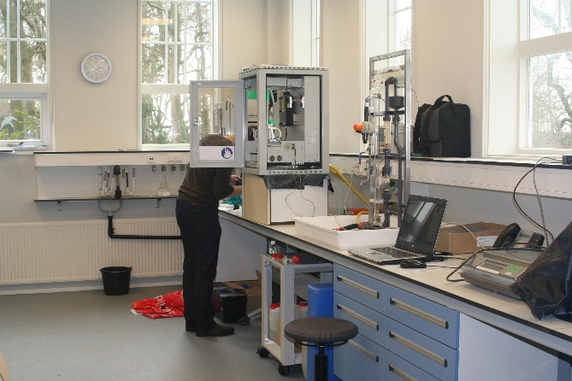
Logo’s: CEW, WA, WaterCampus, en WLN
Pagina 2:
Korte beschrijving: SenTec is a sensor test centre with facilities to test, validate and further develop newly developed sensors for a range of water qualities.
Available water types
- Ground water
- Drinking water
- Surface water
- Demineralised water
Facilities and equipment
- State of the art laboratories (drinking water, chemical and biological)
- access during office hours
- Internet
- Assistance from water specialists and students water technology
- Plug and play
- Possibility to perform long duration test in Drinking Water purification plant
Applications
- Testing and monitoring of water quality in different stages
- Testing and development of sensors and date-measuring equipment
- Tracing contaminants
- On site validation and verification by a high-tech laboratory that is recognized by the ministry of public health
Location
Rijksstraatweg 85
9756 AD Glimmen
The Netherlands
Contact
Jordi Moreno
Email: j.moreno@cew-leeuwarden.nl
Tel: +31 6 57772569

Logo’s van alle partners
